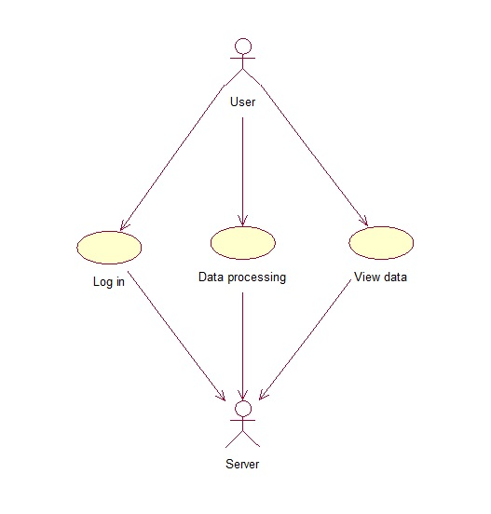

**Events flow for precedent «Log in»**

Short description.

This variant allows users add new account and login in system.

Preconditions.

1. Application checks server connection.

Main events flow.

1. User push button «Login» or «Make new account».
2. User input login for account.
3. User input password for account.
4. User push button «OK».
5. Server confirm that account exists.
6. Application saves new account or login into account.

**Events flow for precedent «Data processing»**

Short description.

This variant allows users delete/create new information about sites.

Preconditions.

1. Application checks server connection.

Main events flow.

1. User push button «Delete» or «Create».
2. User input information into fields.
3. User push button «OK».
4. Server delete/create data.
5. Application shows changes.

**Events flow for precedent «View data»**

Short description.

This variant allows users view data of sites.

Preconditions.

1. Application checks server connection.

Main events flow.

1. User log in into account.
2. Server makes data decrypting.
3. Server gives information of sites.
4. Application shows table with information.